Small animal anaesthesiology seminar
For veterinarians, veterinary assistants and students

When: Friday, November 25,
Where:Latvia University of Agriculture, Faculty of Veterinary medicine
Language: Russian

Speakers:
Aleksandr Semjonov
Veterinary surgeon, lecturer of anesthesiology, surgery and intensive care, Head of Department of Clinical Veterinary Medicine and Animal Clinics, Institute of Veterinary Medicine and Life Sciences, Estonian University of Life Sciences.

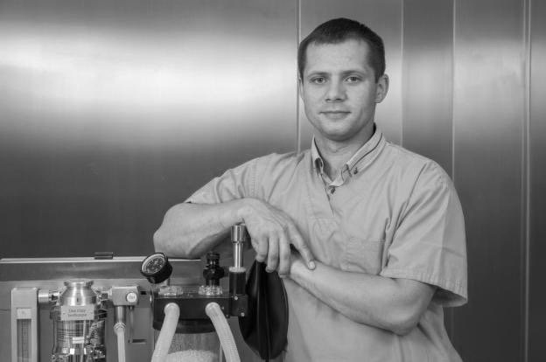
Rihards Čerņevskis
Veterinary surgeon, works at small animal veterinary clinic of Faculty of Veterinary Medicine, Latvia University of Agriculture, guest-assistant at Faculty. Fields of work and interests: anaesthesiology, emergency medicine.

Programm

Time | Topic | Speaker
9:00-9:30 | Registration
9:30 - 11:00 | Anaesthetic risks, physiology of anaesthesia | A.Semjonov
11:00- 11:30 | Coffee break
11:30- 12:15 | Available anaesthetics | R.Čerņevskis
12:15-14:15 | Monitoring and complications | A.Semjonov
14:15-15:00 | Coffee break
15:00-16:30 | Anaesthesia for specific diseases | A.Semjonov

Participation fees:
 | Veterinarians, vet.assistants | Vet. Students
Transfered till 19.11.2016. | 50 € | 30€
If transfered after 19.11.2016. | 70 € | 60€

Please register online here.

Registration is completed after transferring the participation fee.
Students must provide their student ID on registration or send a copy to vicpasts@gmail.com before seminar.
Participation fee includes: Certificate for attendance, course handouts in Russian, coffee breaks.

Course venue: Jelgava, K.Helmaņa 8, Latvia see map here

For invoices: please include details during registration and invoice will be sent to contact e-mail.

Please include your Name, Surname (or name of the participant) at transfer procedure.

Looking forward to welcome you in Jelgava!

Please contact us if needed: vicpasts@gmail.com or 00 371 29449939 (Sandra) or 00 371 26341796 (Anete).

